Update for key stakeholders
28 October 2022

Vaccination
As at 2 November, vaccination figures across the whole of the NHS Highland area were:

 | Over 65s % complete | Health & social care staff % complete | 5-65s at risk % complete
COVID | 69.3 | 36.0 | 23.0
Flu | 64.3 | 36.3 | 20.9

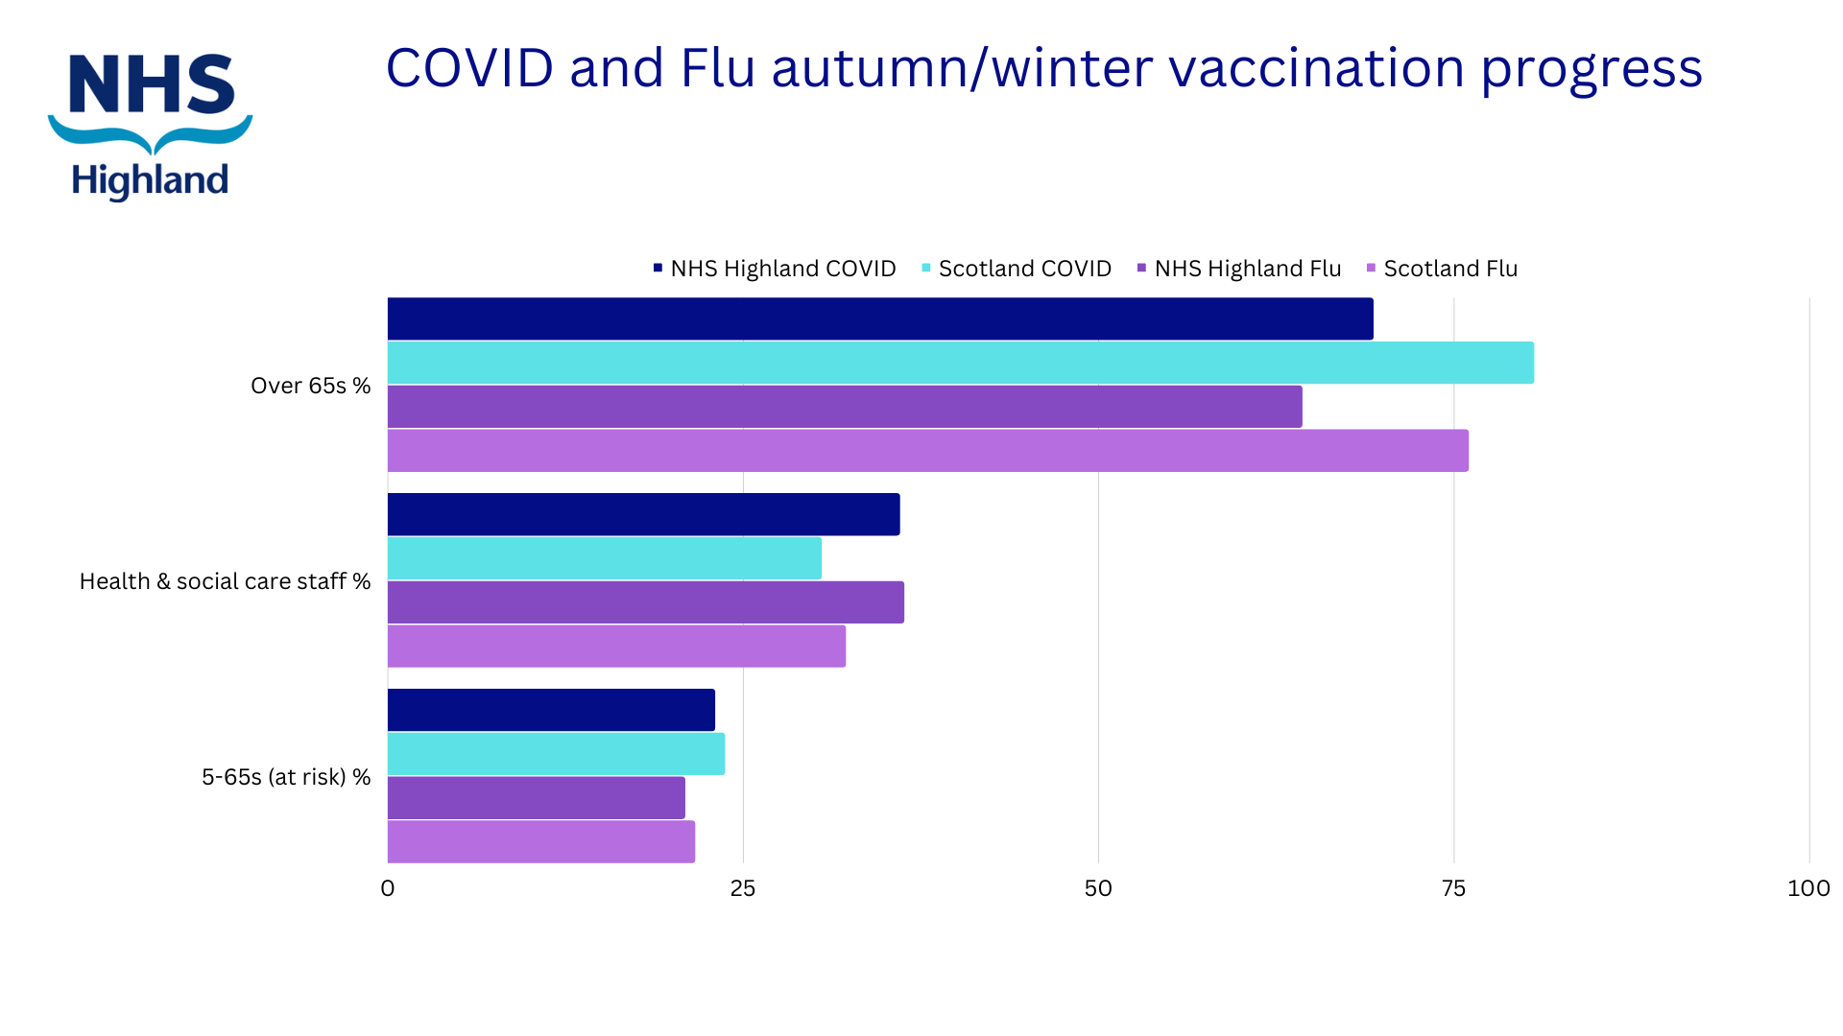

New Website

We are delighted to share that our new corporate website is now live.

Over 250 of the pages most viewed by the public are in the new format and we will continue to move content over. The old site is still available as an archive, linked form the new site.

We would welcome your feedback to Web Manager Kenny Fraser, kenny.fraser@nhs.scot

Feedback
If you have comments or queries please contact nhshighland.feedback@nhs.scot

